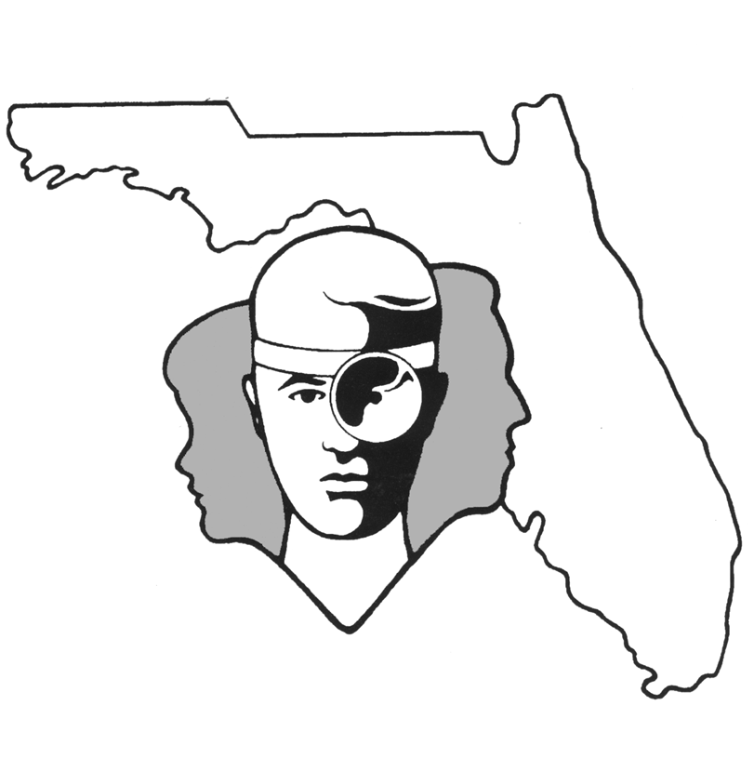
TALLAHASSEE EAR, NOSE & THROAT - HEAD & NECK SURGERY, P.A.

www.TallyENT.com Phone: (850) 877-0101

TYMPANOPLASTY

Your surgeon has recommended a procedure called a tympanoplasty, which is a repair of a damaged eardrum. Most commonly, the damage can be a perforation resulting from trauma, infection, or the extrusion of a surgically placed tube. Sometimes the drum is not perforated, but is instead retracted inwardly by negative pressure behind the eardrum, creating a very thinned out and dysfunctional eardrum that must be replaced. Either of these conditions may lead to symptomatic complaints such as hearing loss, fullness in the ear, or dizziness. However, if the hole is fairly small or if the pocket is fairly shallow, the patient may not have any symptoms at all. In either case, the damaged eardrum should be replaced in order to avoid further complications in the future.

The procedure to repair the eardrum entails removing the damaged portion of the eardrum and “freshening” the edges of any perforation. Attention is then directed to replacement or repair of the eardrum that is now incomplete. There are multiple materials that can be harvested from the body to repair the eardrum, but the most common is temporalis fascia from above and behind the ear. The fascia is the covering over the muscle in that area and is a thin fibrous layer very similar to the eardrum. This can be harvested through a separate small incision just above and behind the ear. If the eardrum is being approached from behind the ear initially, the graft can be also harvested through the same incision as that used to approach the surgical area. Additional sites that are sometimes used include the tragal cartilage, which is the small projection right in front of the ear canal. Sometimes we prefer to use cartilage, particularly for the retracted pockets, in order to prevent them from recurring. In certain rare circumstances we will use other sites such as the opposite ear or possibly a vein from the back of the hand.

The damaged eardrum can be approached either from behind the ear through an incision that runs in the crease between the skull and the back of the ear or through the ear canal itself. This is in large part determined by the severity of damage to the drum, as well as by the location of the damage in the drum. Your surgeon will determine which approach would be best for your particular problem. Once the approach has been determined, the procedure essentially involves creating a trap door flap of skin from the ear canal and the eardrum, and lifting them up so that the middle ear itself is exposed. The damaged portion of the eardrum is removed and the middle ear is packed with a dissolvable gelatin sponge, typically impregnated with antibiotic solution. The graft material is then laid underneath the eardrum where the perforation or retraction pocket was present, and the eardrum is then laid down on top of the graft material. The space on the outside of the eardrum and in the ear canal is then packed with gelatin sponge impregnated with antibiotic solution. The entire procedure may take about 60-90 minutes to perform.

The surgery typically works 90% of the time in repairing the damaged eardrum and correcting any associated problems such as hearing loss. There are multiple factors that determine the potential success including the health of the eardrum surrounding the area that is being repaired, as well as any possible infection that might occur after surgery. Another patient factor that directly determines the success of the surgery includes use of tobacco in the postoperative period which significantly worsens your chance of success. The failure of the drum to heal does not necessarily mean that a revision procedure might fail as well, although it does make it somewhat less likely to succeed.

Possible complications associated with this procedure include a taste change from damaging the nerve that goes to the front two-thirds of the tongue on the same side as that being repaired. Frequently this leads to a metallic type taste that improves over a period of a few months. This does not, however, lead to a significant taste loss in most patients, as over time this becomes something that they adjust to quite well. Additional risks include damage to the hearing, which is very unlikely to occur, with an overall incidence of less than 1%. Even less likely to occur would be damage to the balance system, leading to ongoing dizziness and imbalance. There is also a tiny risk to the nerve that moves the face on the same side as the procedure, but this is an extremely rare complication.

The patient can expect that the ear will be fairly sore for the first week following surgery, and that the hearing will not improve for a period of several weeks due to the packing both under the eardrum as well as on the outside of the eardrum. Frequently the patient will be given an antibiotic to take for the first week postoperatively, and often will be brought in to see the surgeon one to two weeks postoperatively for their first recheck.

